North Cadbury Court Hire

Fridge Trailer £200

For functions and large events it is possible to hire white cloths through North Cadbury Court at a better rate than through hire companies. Please see prices below.

White napkins 51 x 51cm 50p
230cm (90”) round table cloth (for 3’ round tables) £7
305cm (120”) round tablecloth (for 5’ and 5’6ft round tables) £7
330cm (130”) round tablecloth (for 6’ round tables) £7
225cm x 225cm (90” x 90”) £5.50
175cm x 270cm (70” x 108”) (trestle) £4.50
175cm x 175cm (70” x 70”) £4
137cm x 175cm (54” x 70”) £3
137cm x 137cm (54” x 54”) £2.50

All prices are subject to VAT

Limetree Tablecloths
This heavyweight 100% polyester white table linen shows off a crisp, classic linen texture with the soft feel of cotton, with hemmed edges on both the napkins
and tablecloths.
- Fabric: 100% polyester
- Colour: White
- Thread Count: 120
- Yarn Count: 12/12
Weight: 238GSM
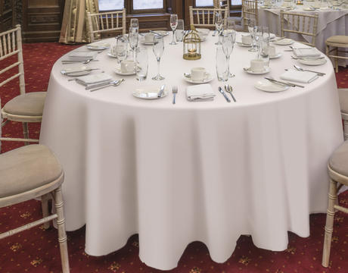

Page 2

Linen supplied with the house

Morning room
2 of 70 x 108 for dining table
2 of 70 x 108 for trestle tables
1 of 228 round for round table

North Hall
H shape table for 50 = 8 of 90 x 90 cloths

