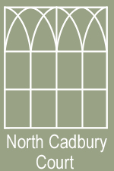

LOCAL WALKS
CADBURY CASTLE (seen from the back of North Cadbury Court)
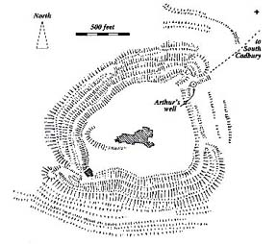
South Cadbury is 1 mile from North Cadbury and is famous as the location of the hill fort of Cadbury Castle, thought by some to be King Arthur's Camelot.
It is a vast Iron Age hill fort covering an area of around 20 acres (8 ha) and the site has seen human occupation from Neolithic times until the late Saxon period. Climb to the top of this hill fort to see history stretching back over 5000 years. Walk the Iron Age ramparts and enjoy spectacular views over the Somerset countryside.
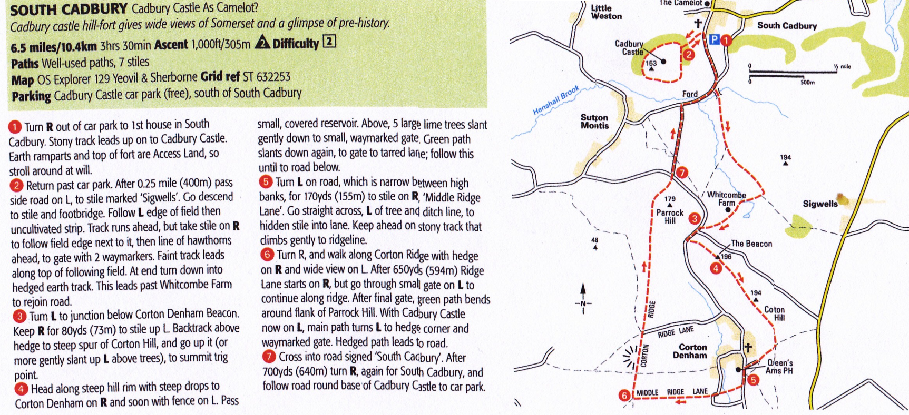
Car Parking available

THE CORKSCREW
A road walk around the lanes surrounding North Cadbury. Turn right out of the gate, walk for approx. half a mile, turn left by the cottage with a conservatory on the side. Keep going left in a loop which brings you back to NCC.
