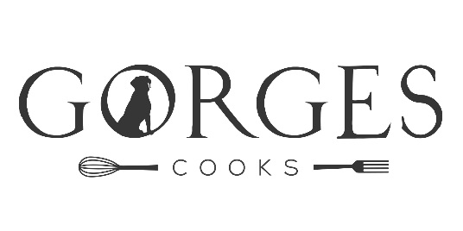
NORTH CADBURY COURT
Menu Suggestions for Delivery Food

MAIN COURSES
Beef Rendang
A favourite curry from West Sumatra, cooked slowly in spiced coconut milk
Served with steamed basmati rice and chutneys

Lasagne (V optional)
Made with a rich beef ragu or as a vegetarian option with roasted squash and spinach
Served with green salad and a selection of artisan breads

Mac ‘n’ Cheese (V)
A comforting, vegetarian, crowd-pleaser
Served with green salad and a selection of artisan breads

Melanzane Parmigiana (V)
Glorious, vegetarian, food from Northern Italy made with aubergine and a rich tomato sauce
Served with green salad and a selection of artisan breads

Moussaka
Made with our lamb, reared in North Cadbury
Served with green salad and a selection of artisan breads

Tagine of Chicken with Preserved Lemons and Olives
Bright, bold flavours of Morocco
Served with a giant cous cous salad with apricots and a citrus dressing

Coronation Chicken
(Served cold)
Served with a wild rice salad, green salad and a selection of artisan breads

Oak smoked fillets of salmon
(Served cold)
with spiced lentils and herby crème fraiche
Served with watercress and pink grapefruit salad

DESSERTS
Apricot and Almond Tart
Deliciously buttery pastry with a light and fruity filling
Served with pouring cream

Banoffee Pie
Made with a ginger base and topped with chocolate shavings

Chocolate Brownies
(Can be GF on request)
Served with vanilla ice cream

Fruit Crumble
Made with seasonal fruits and served with pouring cream

Meringue Roulade
Crisp and chewy meringue with seasonal fruit, homemade curds and cream

Orange and Almond Cake
Served with crème fraiche and pomegranate seeds

Sticky Date Pudding
Served with butterscotch sauce and pouring cream

This is an example menu, provided for illustrative purposes.
We will always tailor menus to the Client’s preferences, taking into account the needs of guests will allergies or dietary intolerances.
We like to use the very best local and seasonal produce and to treat it with respect.
Our flavours are bold, our servings are generous and our presentation is beautiful.

Guide price is £15 Per Head for 2 courses

Please contact Steph to discuss your event
07787 512608
Instagram: gorges_cooks Email: info@gorgescooks.com
Website: www.gorgescooks.com

